CREDIT INVESTIGATION

Screen Shots:
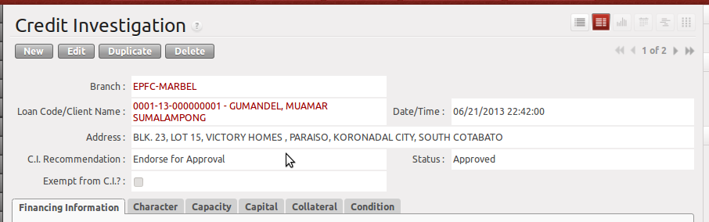

Financing Information

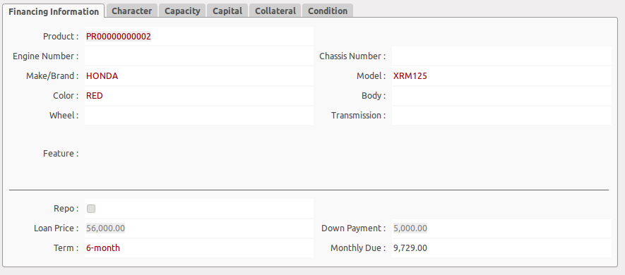
The financing information is automatically filled-up from Loan Application. If the customer wanted to change the quoted unit or change term of payments, you can still update the financing information provided that the record's CI Recommendation is on DRAFT state.

5C's
After the CI/Collector conducted the credit investigation, he has to update the ratings of the 5C's

Character

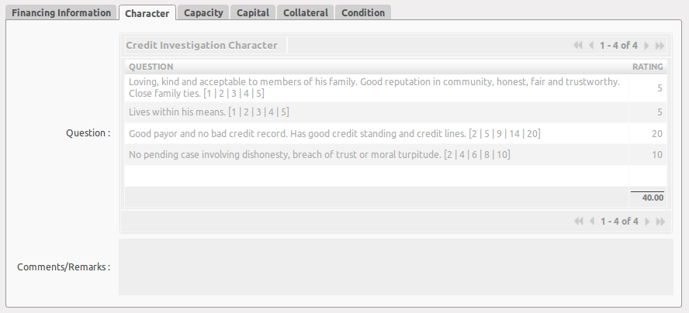

Capacity
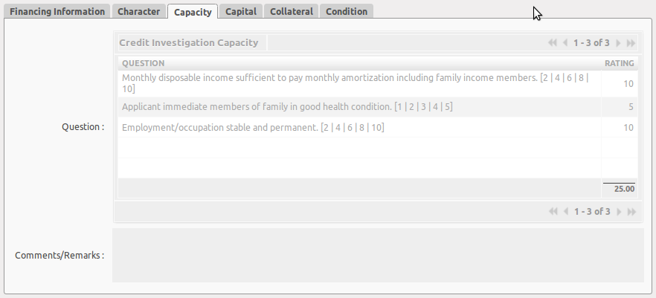

Capital
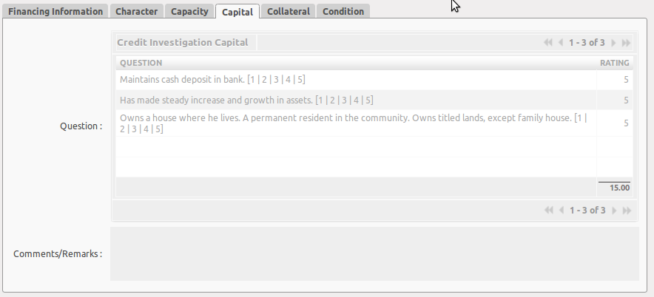

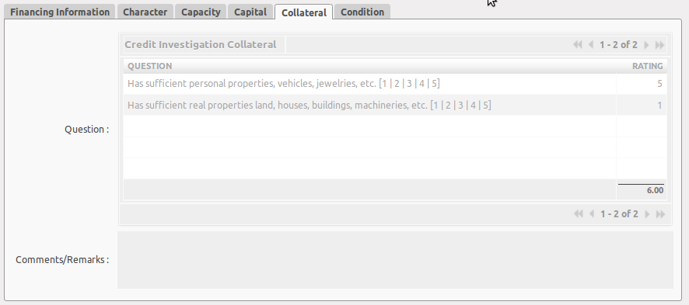
Collateral

Condition

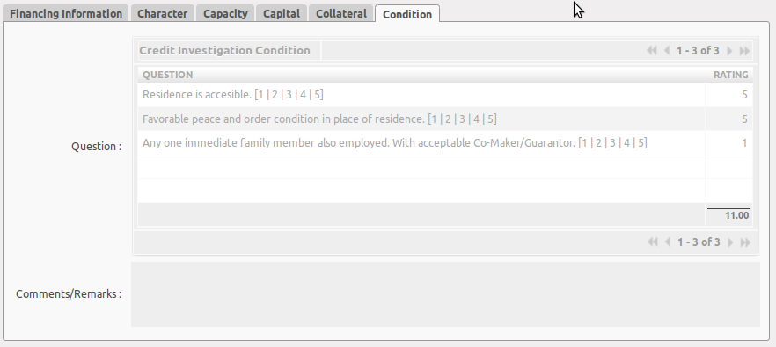

Total Scores and Buttons
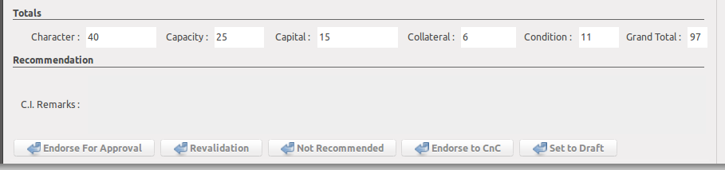
Total scores are automatically updated after the SAVE button is clicked.

Credit Investigation Exemption
A client can be exempted from credit investigation provided that he is qualified for exemption. Exemption reasons are already provided in the system. Exemption reason will only appear if “Exempt from C.I” is checked.

Validations/Criteria
- The C.I. Collector can view/edit only the clients, who is assigned to him (depending on the address of the client).
- The Branch Manager can view only the clients of his branch.
- You cannot create a new record in credit investigation by clicking the new button. The creation of new record will always be initiated from LOAN APPLICATION module.
- When “Exempt from C.I.” is not checked, all the questions in 5C's must have a rating.

